INTEGRATION TESTING

Main Module: SeasonTicket.java

Import Classes:

* ISeasonTicket

Implemented Class:

* ISeasonTicket

Number of methods: 10 and one constructor

Tested Status:

|  |  |  |  |
| --- | --- | --- | --- |
|  | | **Testing Status** | **Bug** |
| **Modules** | SeasonTicket.java | Done | 5 error |
| **Implement Class** | ISeasonTicket | Done |  |
| **Import Classes** | ISeasonTicket | Done |  |

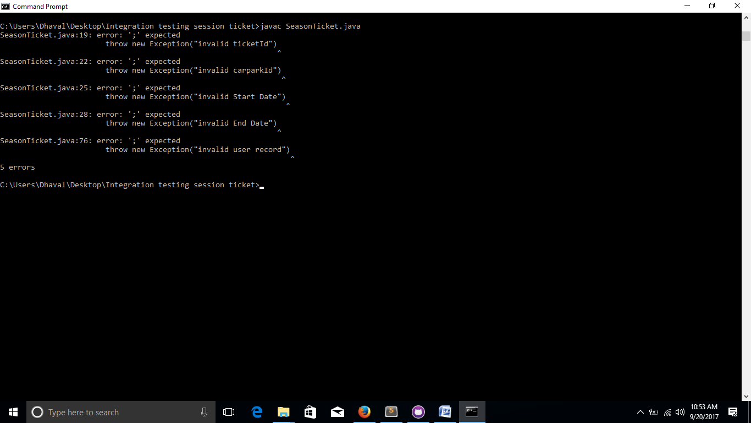

Prepared by: Lavina Patel